How do I connect the handset?

See Diagram:

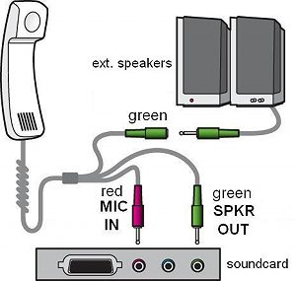Colours and positions of connectors on soundcard may vary among manufacturers | 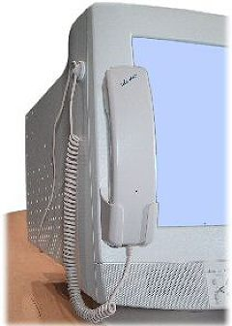

Do I have to adjust sound IN and OUTPUT levels?

Yes, you need to adjust your mic-in volume. As the Noise cancelling microphone is very sensitive, we achieved excellent results with most sound cards by setting the mic-in level to only about 60%. However, most Internet Telephony applications today come with their own Volume Set-up Wizard, so just follow the indications on the screen.
Speaker output level of the sound card can be left at MAX, because you have a volume control on the Handset.

How and where do I mount the handset?

If the front-panel of your monitor is wide enough, we suggest attaching the handset holder on the left front-panel of your monitor. If the front-panel is too narrow you may attach the holder on the side of your monitor.
The cable clamp should be attached on the side towards the top of your monitor to hold the spiral cord conveniently out of your way.
IMPORTANT: Before attaching the holder, clean the mounting area with soap and water, (do NOT use any solvent) and let it dry. Pull off the foil from the adhesive tape and press the holder firmly against the mounting surface. Wait a few hours before hanging up the handset for maximum adhesion.
Flat-Screen:
If you have a Flat-Screen, or if you don’t want to attach the handset to the monitor, you can simply place the handset on the desk, and the switch will function perfectly. The handset is designed in such a way, that you do not need a base!

For further information please check our website at:
www.lets-chat.com/product/faq.html

Product Specification

Internet Telephony Handset IPT 2.1 (let’s chat®)

The let’s chat® IPT 2.1 is the second generation of telephone handsets for computers, specifically designed for home / SOHO users of Internet telephony.
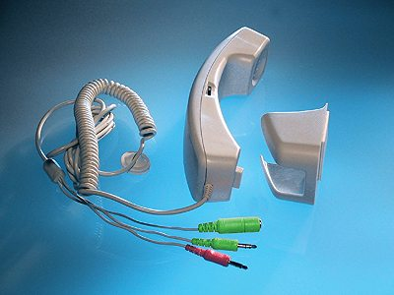

Feature-rich and yet affordable!
It connects to the PC’s sound card and allows the external PC-speakers to be re-connected.
Its main advantage is the automatic muting of the PC-speakers when it’s lifted from its holder or from the desk. There is no need to lower the volume or disconnect the PC-speakers during a phone call.
This also permits users to receive incoming ”phone to PC” calls while online.
It further includes a thumb-wheel volume control for the earpiece, therefore no need to adjust volume in the program set-up during a conversation.

Application examples and areas of use

- whenever a PC is used as a phone
- PC-to-PC, PC-to-phone and phone-to-PC Internet telephony
- click-to-call services
- universal computer microphone

Features and benefits

- PC speakers can be connected to the auxiliary female stereo plug
- PC speakers are muted when the handset is lifted from it’s holder or from the desk
- shielded, extra-long, partially coiled cord with a self-adhesive fixing clip
- the cord is sufficiently long to reach under-the-table PCs
- convenient earpiece volume control
- self adhesive handset holder for mounting on the PC monitor; frees table space
- Mylar speaker (does not influence colour of the screen)
- high quality, noise cancelling microphone
- easy to install and to operate; only one connection cable; works with any IP telephony, voice or sound application

Technical specifications (typical values)

PARAMETER | VALUE/DEVICE | NOTES
Microphone Sensitivity | -45±4dB | 0dB = 1V/Pa, 1kHz
Frequency range | 20 – 16.000 Hz
Impedance | Less than 2.2kΩ (1kHz)
Speaker frequency response | 50 Hz - 15 kHz | 30 mm Mylar Cone
Speaker impedance | 32 ohm at 1 kHz
PC speaker muting attenuation | 100 dB
Type of connectors | 3.5 mm stereo plug | 2 male, 1 female
Length of connection cord | 200/280 cm | Unstretched/fully stretched
Patented switching circuit, let’s chat ® is a registered Trademark of ITEM intl. www.lets-chat.com
ITEM intl. reserves the right to change the specifications without prior notice. V2.0 10/2006

